# **PAPER TITLE**

Author Name 1, Affiliation, ORCID, Country, Email

Author Name 2, Affiliation, ORCID, Country, Email

Author Name 3, Affiliation, ORCID, Country, Email

Axis:

## Introduction

The introduction should present the general theme of the research. Present the research problem, the justification for the importance of the research and the general and specific objectives of the research.

## Theoretical Framework

The theoretical framework must present the most relevant theoretical currents, concepts and authors that supported the development of this research.

## Methodological Procedures

Briefly explain the methodological procedures applied in the research: nature/approach of the research (qualitative; quantitative; qualitative-quantitative), type of research (descriptive; exploratory; bibliographic; documentary; etc.), research method (Content Analysis; Ethnography; etc.), research universe, target population and research subjects, data collection techniques (interview; questionnaire; observation; etc.), data collection instruments (scripts; *checklist* ; indicators; protocols; etc.), data collection instruments (scripts; *checklist* ; indicators; protocols; etc.), research universe, target population and research subjects, data collection techniques (interview; questionnaire; observation; etc.), data collection instruments (scripts; *checklist* ; indicators; protocols; etc.), collection procedures (scheduling, consent forms, etc.) and, finally, data analysis procedures.

## Partial or Final Results

Objectively present the expected and/or achieved results.

## Partial or Final Considerations

Present the reflections made so far, as well as the relevant aspects of the research (impacts, contributions, limitations, etc.).

## Formatting

Details regarding the preparation of the extended summary are presented in subsections 6.1; 6.2; 6.3; 6.4; 6.5; 6.6; 6.7; and 6.8.

### **Subsections**

Subsections should be subdivided in such a way that they are visually evident. Use progressive document numbering, according to this *model.*

### **General Formatting**

* The extended abstract should have a maximum of 4 thousand words (excluding bibliography) for full papers and 2 thousand words (excluding bibliography) for posters.
* Calibri font, size 11, single-spaced and must contain:
  + Title
  + Author(s) name(s), affiliation(s), ORCID number, country and email address(es)
  + Present: the general theme, the objectives, the hypotheses or assumptions, the methodology, the relevant theoretical framework, the partial or final results, the partial or final conclusions.
* The full text must contain a maximum of 10 thousand words (including bibliography) and 7 thousand words (including bibliography) for posters.
* Send the full text in .DOC or DOCX format, Calibri font, size 11, single spacing and must contain
* Title
* Author(s) name(s), affiliation(s), ORCID number, country and email address(es)
* Present: the general theme, the objectives, the hypotheses or assumptions, the methodology, the theoretical framework, the partial or final results, the partial or final conclusions.
* Section titles should be written in Calibri, size 11, bold.
* The text must be written in Calibri font, size 11.
* The use of bold, italics or underlining should only be used in the body of the text if absolutely necessary.
* The full name must be indicated first, followed by the acronym in parentheses. Ex: Asociación de Educación e Investigación en Ciencias de la Información de Iberoamérica y el Caribe (EDICIC).
* Words in a foreign language should be written in italics. For example: *apud* ; *et al* .; *Information Science* ; *Library Science* ; *Archival Science* ; *Museology* .

### **Citations**

The block quote must be written in Calibri font, size 10, 2 cm from the margin, 6pt before and 6pt after, applying the *American Psychological Association* (APA), 7th edition, as examples for one author, two authors, three authors or more:

The blocked citation should be written in this form (Giddens, 1978, pp.25-30).

According to Giddens (1978, pp.25-30), the blocked quotation should be written in this way.

A block quote should be written in this way (Wegener & Petty, 1994, pp.34-42).

According to Wegener & Petty (1994, pp.34-42), the block quote should be written in this way.

The block quote should be written like this (Harris *et al* ., 2018, pp.58-67).

According to Harris *et al* . (2018, pp.58-67), the block quote should be written in this way.

A block quote should be written like this (Boser, 2017, cited in Brown, 2018).

According to Boser (2017, cited in Brown, 2018), the block quote should be written in this way.

### **Figures**

Figures that do not fit in the column space should be placed at the end of the extended abstract. They should be presented in good resolution so that they can be viewed without problems. Ex:

**Figure 1: Figure title**

**Source: https://br.pinterest.com/pin/853854410597809977/ (2025).**

If figures are larger than this space, they should fit within the text or be placed at the end of the extended abstract.

* 1. **Graphics**

Graphs that do not fit in the column space should be placed at the end of the extended summary. They should be presented in good resolution so that they are easy to view. For example:

**Figure 1: Graphic title**

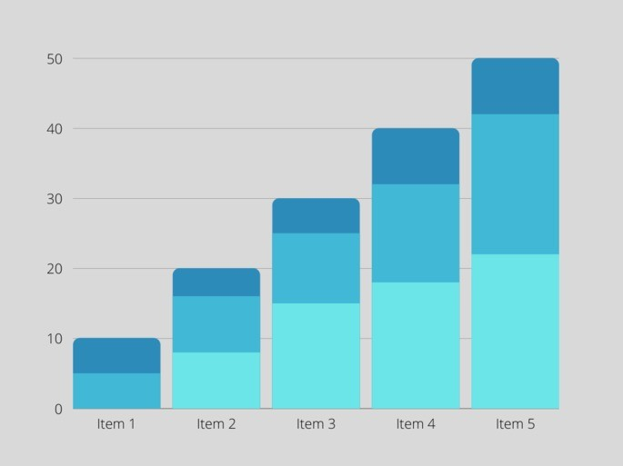

**Source:** [**https://www.diferencia.com/tipos-de-grafico/**](https://www.diferenca.com/tipos-de-grafico/) **(2025).**

### **Frames**

Frames contain text, i.e. they generally do not contain numbers or percentages. They should be presented as follows. For example:

**Table 1: Frame title**

|  |  |  |
| --- | --- | --- |
| **Database** | **Content** | **Year** |
| *Web of Science* (WoS) | Provides subscription access to multiple databases. Originally produced by the *Institute for Scientific Information* and currently maintained by *Clarivate Analytics.* | 1997 |
| *Library and Information Science*  *Abstracts (LISA)* | Includes more than 440 magazines from over 68 countries and in more than 20 different languages. | 1969 |
| SCOPEUS | Database of academic and scientific articles. Covers around 19,500 titles from over 5,000 international publishers. | 2004 |

**Source: Own elaboration (2025).**

### **Tables**

The tables contain numbers and percentages. They should be presented as follows. For example:

**Table 1: Table title**

|  |  |
| --- | --- |
| **Style** | **%** |
| Style 1 | 10% |
| style 2 | 20% |
| Style 3 | 30% |
| style 4 | 40% |
| **Total** | **100%** |

**Source: Own elaboration (2025).**

### **References**

Bibliographic references must follow the standards *of the American Psychological Association (APA), 7th ed.,* Calibri font, size 10, with 0.7cm displacement, according to the examples in 6.8.1; 6.8.2; 6.8.3; 6.8.4; 6.8.5; 6.8.6; 6.8.7; 6.8.8; and 6.8.9. Important: The references must be presented in unique alphabetical order.

### Books

King, M. L., Jr. (2010). Stride toward freedom: The Montgomery story. Beacon Press.

DiFonzo, N., & Bordia, P. (2007). Rumor psychology: Social and organizational approaches. American Psychological Association.

### Book Chapters

Burke, W. W., & Nourmair, D. A. (2001). The role of personality assessment in organizational development. In J. Waclawski & A. H. Church (Eds.), Organization development: A data-driven approach to organizational change (pp. 55–77). Jossey-Bass.

Posluszny, D., Spencer, S., & Baum, A. (2007). Posttraumatic stress disorder. In S. Ayers, A. Baum, C. McManus, & et. al. (Eds.), Cambridge handbook of psychology, health and medicine (2nd ed.). Cambridge University Press.

### Journals Articles

Bishop, M. D. (2006). Public opinion and juvenile justice policy: myths and misconceptions. Criminology and Public Policy, 5(4), 653-664. <https://doi.org/10.1111/j.1745-9133.2006.00408.x>

Somers, CL, Day, AG, Niewiadomski, J., Sutter, C., Baroni, BA, & Hong, J. S. (2018). Understanding how school climate affects overall mood in residential care: Perspectives of adolescent girls in foster care and juvenile justice systems. Juvenile & Family Court Journal, 69(4), 43-58. https://doi.org/10.1111/jfcj.12120.

### Papers Published in Event Proceedings

Davidson, R. J. (2019, August 8–11). Well-being is a skill [Conference session]. APA Convention 2019, Chicago, IL, United States. <https://irp-cdn.multiscreensite.com/a5ea5d51/files/uploaded/APA2019_Program_190708.pdf>

Fistek, A., Jester, E., & Sonnenberg, K. (2017, July 12-15). Everyone has a little music in them: Using music therapy to connect, engage, and motivate [conference session]. Autism Society National Conference, Milwaukee, WI, United States. https://asa.confex.com/asa/2017/webprogramarchives/Session9517.html.

### Theses/Dissertations

Thomas, G. (2014). The influence of homeland security on policing (Publication no. 3645567) [PhD dissertation, Indiana University of Pennsylvania]. ProQuest Dissertations and Theses Global.

Gerena, C. (2015). Positive Thinking in Dance: The Benefits of Positive Self-Talk Practice in Conjunction with Somatic Exercises for Collegiate Dancers [master's thesis, University of California Irvine]. University of California, eScholarship. https://scholarship.org/uc/item/1t39b6g3.

### *Web* Environment

Chandler, N. (2020, April 9). What’s the Difference Between Sasquatch and Bigfoot? https://science.howstuffworks.com/science-vs-myth/strange-creatures/sasquatch-bigfoot-difference.htm.

Kamin, H. S., Lee, C. L., & McAdoo, T. L. (2020). Creating References Using APA Style Seventh Edition [Webinar]. American Psychological Association. <https://apastyle.apa.org/instructional-aids/tutorials-webinars>.

* + 1. Videos

Staveley-Taylor, H. (Director) (2006). Introduction to Experience Design [Film; DVD]. Uniview Worldwide; Cambridge Educational.

Above The Noise (2017, October 18). Procrastination can be a good thing [Video]. YouTube. https://www.youtube.com/watch?v=FQMwmBNNOnQ.

* + 1. Sounds

Nirvana (1991). Smells like teen spirit [Song]. In Nevermind. DGC.

Andrews, F. (2009). The house she lived in [Song recorded by The Veils]. In Sun Gangs. Rough Trade.

* + 1. *Podcasts*

Santos, L. (Host). (nd) Psychopaths and superheroes (No. 1) [Audio podcast episode]. In The happiness lab with Dr. Laurie Santos. Pushkin Industries. https://www.happinesslab.fm/season-2-episodes/episode-1.

Hersher, R. (2020, March 19). Spring starts today all over america which is weird [Radio broad-cast]. NPR. https://www.npr.org/2020/03/19/817237429/spring-starts-today-all-over-america-which-is-weird.

### **Notes**

Explanatory notes should be used exceptionally. Do not use footnotes, but rather endnotes. For example:

**NOTES**

1 Footnotes should appear at the end of the text.

2 Footnotes should appear at the end of the text.